Name _____________________________________________________________________________________________ Biome ________________________________________
World Region _______________________________
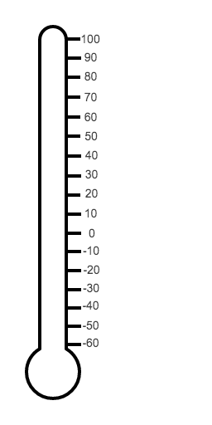
900 cm

450 cm

0 cm

Producers | Consumers | Decomposers

Population

Needs
Individual | Population
Water
Food
Living Space
Homeostasis

Population Interactions
Cooperation | Competition | Social Hierarchy | Territorialism

Organisms/Individuals

Organ Systems
Organs
Tissues
Cells

Cycle of Matter
Water | Nitrogen | Carbon-Oxygen
Eutrophication:

Responses Over Time
Phototropism | Hibernation | Dormancy

Community Interactions
Predation | Competition | Symbiotic Relationships
 |  | Parasitism | Commensalism | Mutualism

