Name:_____Answer Key__________________________Period:______
Unit 2: Cell Structure and Function Study Guide
1. Identify the major functions of cell structures and cell organelles including:
Organelle | Function
Cell Wall | Provides structure and support for the cell
Cell Membrane | Controls what enters and exits the cell
Chloroplast | Captures energy from the sun to produce food for the cell
Chromatin/DNA | Thin strands of genetic material with instructions directing the cell’s functions.
Cytoplasm | Gel-like fluid that holds the other organelles in place.
Endoplasmic Reticulum | Transports material around the cell.
Mitochondria | Produces energy for the cell. The “powerhouse”.
Nucleus | Contains the DNA, directs cell activities
Vacuole | Stores water, food, wastes

2. Given an image of a cell, be able to identify:
Cell Membrane

Endoplasmic Reticulum

vacuole
cell membrane

nucleus
mitochondria
cytoplasm
chloroplast

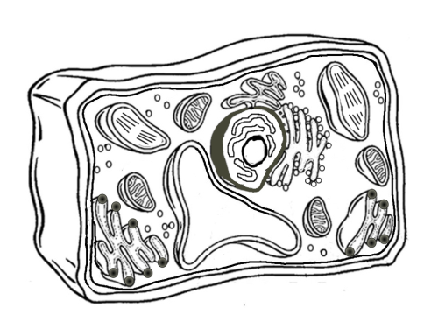
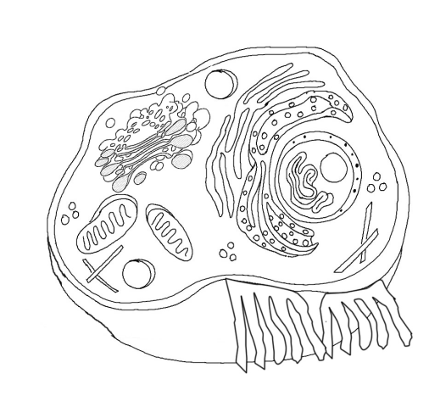
nucleus
cytoplasm
Endoplasmic reticulum
central vacuole
cell wall
mitochondria
3. What evidence would you use to determine if a cell is plant cell or animal cell?
If it is a plant cell:
- the cell might be green due to chloroplasts
- Will have a cell wall (rectangular shape)
- Central vacuole
If it is an animal cell:
- may have lysosomes
4. What is the difference in the structure, function, and organization of life between unicellular organisms and multicellular organisms?
 | Unicellular | Multicellular
Structure | One cell=the organism | The organism is composed of more than one cell and the cells may be all different shapes and sizes based on the function they perform for the organism.
Function | The single-celled organism must perform all of the functions of life within one cell. | Multicellular organisms tend to be more complex because they can distribute different functions to specialized cells. For example: skin cells, root cells in plants, stomach cells, brain cells, etc.
Organization | Unicellular organisms consist of a single cell-the simplest level of organization. | Multicellular organisms have specialized cells that perform specific functions for the organism. The cells work together to create tissue that perform a specific function. Tissues may work together to create organs that perform a specific function. Organs may work together to create systems that perform specific functions. All of the systems, working together, perform the functions of life for the organism.

5. Know the organization of life:
cells-_tissue_______ ____organ_______-__system____________ _organism____________
(Sometime Organ Systems are simply called Systems)

6. Understand the relationships between the levels of organization. For example:
Tissue is made up of?__specialized cells that perform a specific function__________
Systems are made up of? _organs ________________
Organisms are made up of? __systems_________
Organs are made up of? __2 or more types of tissues_______________

7. Would a tissue or an organ have greater variety specialized cells? Explain.
An organ would have greater variety of specialized cells because tissue is made up of just one type of specialized cell whereas organs are made up of two or more types of tissues, which means they include at least two different types of specialized cells.
8. Differentiate (compare and contrast) between unicellular vs. multicellular cells and animal vs. plant cells.
Unicellular would be a single cell moving and performing the functions of life on its own. A multicellular organism would be a collection of cells, probably attached to one another so that they could perform the functions of life at the cellular, tissue, organ, and system level for the organism.
Unlike animal cells, plant cells tend to be rectangular in shape due to their cell wall. They are often green if they contain chloroplasts (though not all cells in plants contain chloroplasts-it depends on their function for the plant). The large central vacuole may also be visible.
Animal cells have lysosomes whereas plant cells do not.

9. Compare and contrast diffusion and osmosis.
Diffusion is the movement of molecules from an area of high concentration to an area of low concentration.
Osmosis is specifically the diffusion of water through a selectively permeable membrane from an area of high concentration to an area of low concentration.

10. Define concentration.
The amount of substance in a given volume/area.

11. Draw a picture of what would occur if an elodea (aquatic freshwater plant) is placed in salt water.
elodea in fresh water elodea in salt water
In salt water, there is a higher concentration of water inside the cell and a lower concentration of water outside of the cell. Through the process of osmosis, water will diffuse out of the cell.
water

