Name __________________________________ Period _______
Assigned: Wednesday, February 10 Due: Monday, February 21

DNA, RNA and Cell Cycle Study Guide

- Diagram and describe the form of DNA as chromatin, chromosome and chromatids

- Identify this structure and the name the shape.
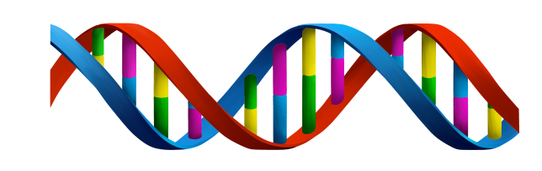

- How does DNA store genetic information?

- Identify the base pairing rules of DNA.

- Complete the complementary strand of DNA

A T T T G G C A T

- What are the two steps of DNA replication?
1.

2.

- Why is DNA replication necessary?

- Identify the three scientists discussed in class and their contributions to the discovery of the structure of DNA.
1.

2.

3.

- DNA is essential to living organisms because it carries the _______________________

- Diagram and label the shape of the DNA structure.

- Describe the molecular structure that makeup a strand of DNA.

- What are chromosomes?

- What are genes?

- What are alleles?

- Explain the relationship among chromosomes, genes and alleles.

- How is the information stored in DNA used by the cell?

- What Nitrogen base is found in RNA and not in DNA?

- For the DNA strand below, write the complementary base pairing sequence of RNA.

A G C T T A C C A G

- What is the cell cycle?

- What is the purpose of the cell cycle?

- Draw a pie chart showing the amount of time an average cell spends in each stage of the cell cycle.

- Diagram the cell cycle in the correct order. Be sure to label each stage in the cell cycle and each phase of mitosis.

- Explain what is occurring in each phase of the cell cycle. Be sure to use the correct term for the form of DNA.
  - Interphase

  - Prophase

  - Metaphase

  - Anaphase

  - Telophase

  - Cytokinesis

- What happens to the cell after cytokinesis?

- What role does mitosis play in the cell cycle?

