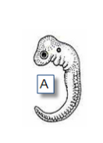

#1

________________ _________________ ________________ _________________ _________________ _________________

#1

________________ _________________ ________________ _________________ _________________ _________________

#1

________________ _________________ ________________ _________________ _________________ _________________

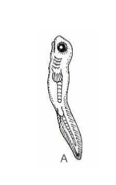
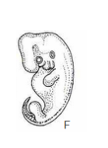
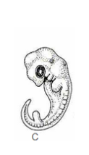
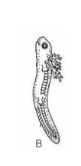

#2

________________ ________________ ________________ ________________ ________________ ________________

#2

________________ ________________ ________________ ________________ ________________ ________________

#2

________________ ________________ ________________ ________________ ________________ ________________
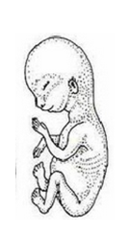
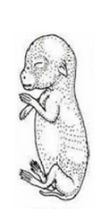
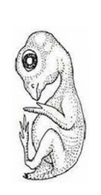
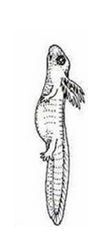
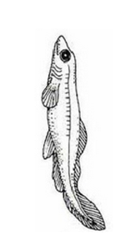

#3

A B C D E F ________________ _________________ _______________ _______________ ______________ _______________
#3

A B C D E F
________________ _________________ _______________ _______________ ______________ _______________

#3

A B C D E F
________________ _________________ _______________ _______________ ______________ _______________

