Fossil Station
- Remove the images of fossils from the bag.
- Spread the cards out on your desk with the following card at the bottom (the oldest
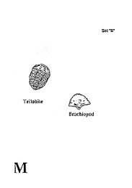

- Begin with the card labeled “m” as the oldest fossil (the bottom layer of rock).
- Organize the cards from “m” (the oldest fossils) up to the newest.
- Remember, once an organism goes extinct, it cannot appear later in the fossil record.
- Use your iPad to take a picture and annotate your sort.
  - Annotate which level is oldest
  - Which level is youngest
  - Circle when an organisms goes extinct.
Why are some fossils in some layers of rock but not in others?

Why are fossils in the deeper layers more primitive (less complex)?

Examine the whale fossils. Organize the ancestors of today’s whales in order from oldest to most recent using clues in the fossils.

Using both of these activities as evidence, how can the fossil record be used as evidence for evolution?

How is the fossil record also a record of life on Earth?

If you finish early please explore the qr code.

