Cell Cycle

Cytokinesis

Mitosis

Interphase

Protein Synthesis

RNA:

* ____________________ Helix
* ____________________ pairs with Adenine

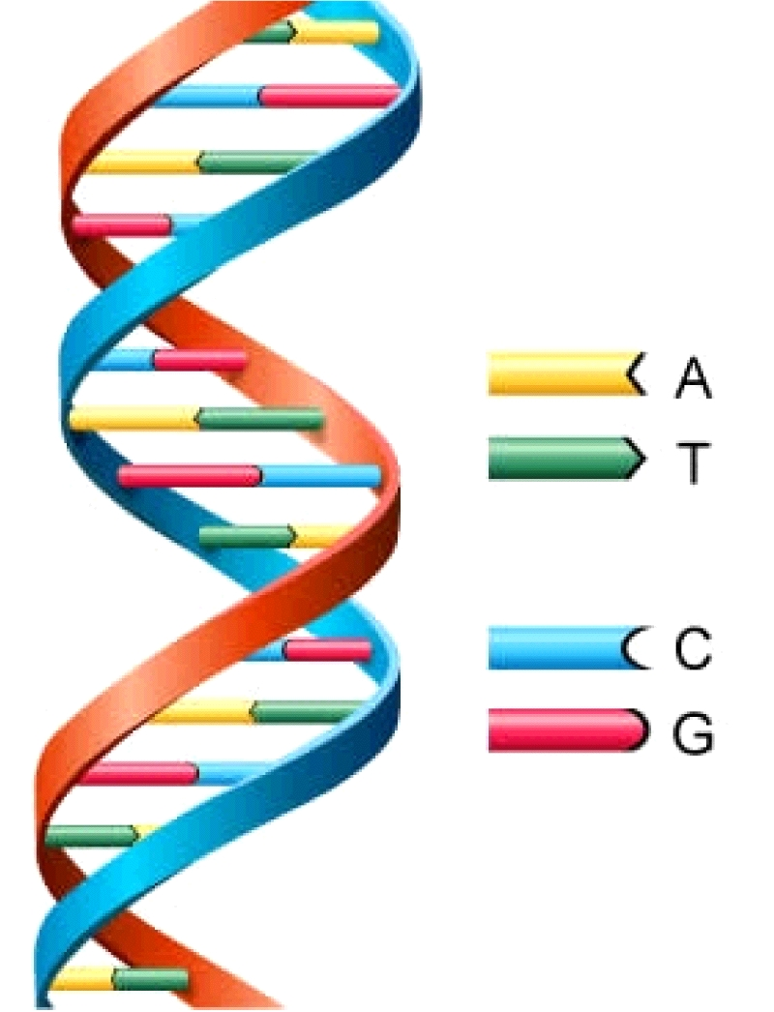Ribosome: _______________________________________________________________ _______________________________________________________________

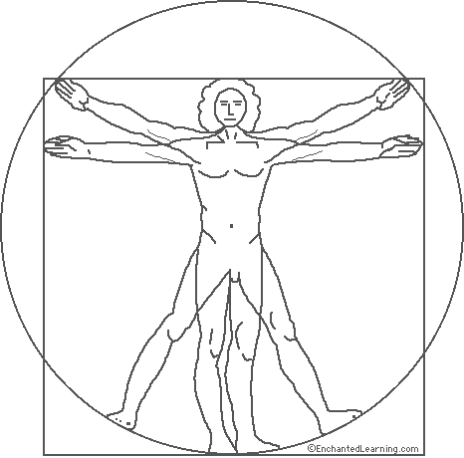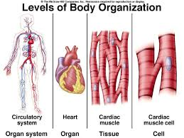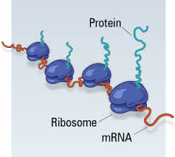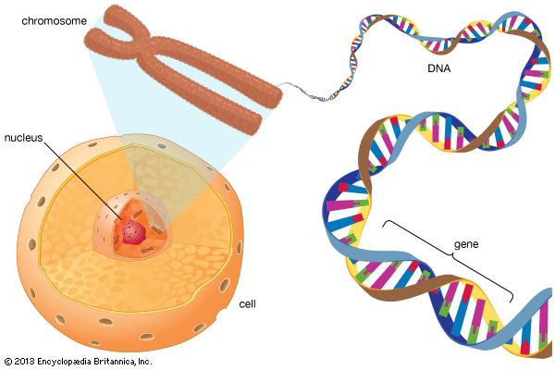

DNA

Nucleus

Ribosome

Proteins

Organelles

Cells

Tissues

Organs

Organ Systems

Organism