Darwin and Natural Selection
Directions: Snap the QR card or go to Google Classroom and watch the Galapagos Islands, Finches and Evolution video. (Google Classroom plays in Full screen QR does not.)

- Charles Darwin’s voyage on the H.M.S. Beagle led him to hypothesize how life changes over time. Darwin called it descent with modification but today the idea is called __________________________

- Darwin noticed that the characteristics of ___________________________ and plants were different from island to island.

- Humans, specifically farmers, have been engaged in artificial selection for many generations in order to create species that produce the best crop or fastest horses. Darwin used this knowledge to explain how this process could occur in nature. Since it is nature selecting the best traits for that environment, Darwin called it natural selection. Infer how Charles Darwin’s curiosity, analytical thinking and use of background knowledge contributed to his success as a scientist.

- Look at the diagram below that shows the tortoises of the Galapagos Islands and answer the questions that follow.
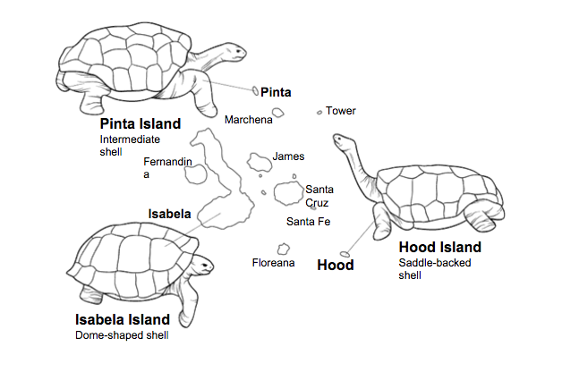

Which one of the turtles would most easily be able to obtain food that is hard to reach? Explain.

Compare the tortoises and the finches of the Galapagos Islands to the Bird Beak Lab.

- Read the text and look at the visual in the diagram below and answer the question that follows.

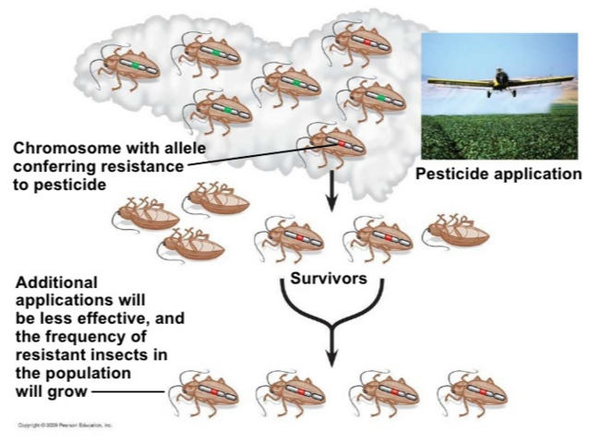

A pesticide is a chemical used to kill pests (bugs). Explain why some insects died and others survived.

- Some insects look just like sticks.
  - How could this be an advantage to the insect?

  - How could this trait have evolved through natural selection?

